

***Transforming lives in Zambia by strengthening the church, educating the next generation, and serving the community in the name of Jesus Christ.***

###### Ndola, Zambia

May 2014

Volume 6, Issue 2

### Inside This Issue

Big Changes 1

From Teacher Amy 2

Sponsor A Teacher, C2C4Jesus 3

Pictures of the new Luanshya School 3

Building Progress! 4

Saying Good-bye, Trip Information 5

# Big Changes

*Vince Smith*

*Chairman, Haven of Hope Ministries*

Hello Friends,

We continue to stand in awe of all that God is doing! We never take for granted all of you who choose to partner with Haven of Hope in making a difference in the lives of countless orphans and vulnerable children. Thank you for sponsoring, supporting, giving, praying, encouraging, serving, and sacrificing in so many ways! Together we are being used by God to save lives both physically and spiritually!

The students in Luanshya were able to start the May school term in their new building! What a huge blessing and answer to so many prayers. Please be sure to check out the pictures and read teacher Amy’s update with more of the details.

The 4th annual fundraising banquet was a huge success with 174 people in attendance and more than $25,000 given in connection to the dinner! I must add that 100% of the $25,000 given will go directly into the ministry since our table sponsors completely underwrote the cost of the dinner! We owe a great big thank you to our table sponsors and table hosts who made the dinner a success! We were delighted that John Banda and Amy Munn were able to be in the US to speak. If you missed the banquet you can still go online to hear the speakers. Go to [www.havenofhopezambia.org](http://www.havenofhopezambia.org), click on sponsorship, and then choose media from the drop down menu, then videos, then 4th Annual Fundraising Dinner.

Another big change for Haven of Hope is a transition in the Communication Liaison position. You’ll likely still see Marci Bidelspach around at Haven of Hope functions, but after this week she will no longer be serving as our communication liaison. Marci has served the children, Zambia staff, and all of us here in the US very well over the past 6 years. She has been the voice of Haven of Hope for so many of you. As sponsors you heard from her often. She passionately pursued the best possible communication between the sponsors and the students in Zambia. She faithfully ensured that sponsorship payments were up to date and that Christmas gifts were ready to be delivered to every student at Christmas time. Marci has shouldered a lot of work and done much to defend the cause of the orphan! We are extremely grateful for all that she has done to help this ministry grow from serving a few students in 2007 until now with an ever increasing work load of 205 precious students. Her presence at our US office will be missed!

Communication with our office can now be directed to the following email address, [info@havenofhopezambia.org](mailto:info@havenofhopezambia.org). Kara Smith will be serving as our interim communication liaison until the end of August when she heads off to college. Beth Hartman will also be picking up several of the communication liaison responsibilities. Both of these ladies look forward to serving you in the months ahead. As Haven of Hope continues to serve more children in Zambia we are experiencing an increased need in the number of hours needed to meet the needs. The Haven of Hope board is in the process of evaluating our current staffing needs. We never dreamed that God would allow us the privilege of serving so many precious children in Zambia. We know He has so much more in store as we continue to look after orphans! Please be praying with us as we look to develop a solid infrastructure to support the future growth of this ministry.

Because it Matters,

Vince Smith

[http://l.yimg.com/g/images/spaceball.gif](http://www.flickr.com/photos/51677476@N05/4759760035/)

Moments when the kids you THINK have changed revert back to old behaviors. Days when you feel like you’re just telling students to be quiet and listen rather than actually teaching. But then there are days when an 11 year old girl who started grade 2 in February without knowing a single letter or how to even add 2 + 2 suddenly gets 100% on her math work and raises her hand with pride to read a sentence on the board. Or days when you get to watch your kids working together to clean the plates in the hot sun, giggling the whole time. Or days when a mother can bring her two sick children to school, knowing that we will provide a way for her to take them to the clinic to get the medicine they need. Those are the moments that make it all worth it.

I just want to continue thanking you all for what you have done for me and the students at Haven of Hope. We are greatly blessed by your generosity and encouragement. I am so excited to see what God has in store for this school and I am truly honored to be a part of it all.

In Him,

Amy Munn

# From Teacher Amy

*Amy Munn, Teacher*

*Haven of Hope Schools, Luanshya*

I can’t believe it’s May already -- almost 2 years since I arrived in Zambia for this amazing adventure. For those of you who don’t know, I just spent our April holiday back in the US. It was such a wonderful, much-needed month of rest and rejuvenation. I was so blessed to spend time with many of you, and I thank you for your continued encouragement and support. I loved getting to spend time with John and some of our American team at the CAFO conference in Chicago, learning more about how to best serve vulnerable children around the world. I walked away from that time even more confident that God has called me to Zambia and the students of Haven of Hope for this period of my life and I was so excited to get back and continue the story.

We started our second term last Monday and it’s been quite a fun change so far. Here in Luanshya, we are now meeting at our newly purchased and renovated house about two minutes from the old school. I can’t tell you what an incredible blessing it is to have five separate classrooms for our five grade levels!

We were even able to purchase ten new desks, which are beautiful and SO much nicer than our old wooden desks. These might seem like small things, but after sharing the office for your classroom and teaching 16 students while they sit on the floor, you come to truly understand what a blessing they are. I can’t say thank you enough to those who made this move possible. It is so exciting to watch the students make this new school their own and take responsibility for keeping it in good condition. I can’t wait to see how God expands our impact through this new building.

I’ve loved being back in Zambia, and I truly feel like my heart is ready to continue the battle for my students’ futures. Yes, there are always going to be moments of discouragement.

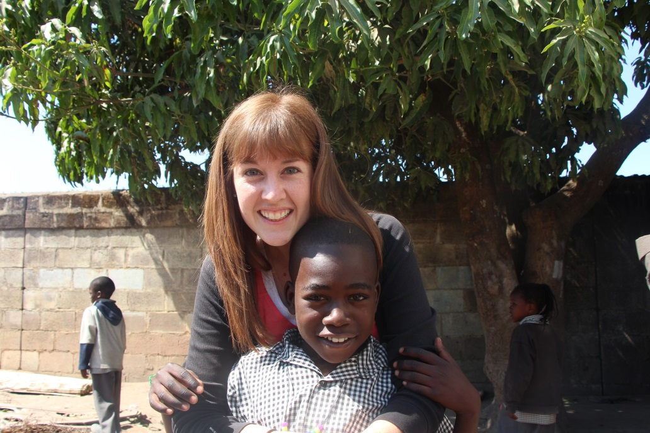

# C2C4 Jesus!

# Sponsor a Teacher!

Haven of Hope is partnering with Penns Valley Family Life Church and we encourage you to pray for this upcoming event C2C4 Jesus (Coast to Coast for Jesus). You can find out more details at their website:

[www.c2c4jesus.org](http://www.c2c4jesus.org)

“The number “2” stands for “two of us” that will be biking from Coast to Coast and taking the Gospel with us!  The funds raised will go to build an orphanage overseas, dig fresh water wells in villages that have none and to build our Worship Center for Family Life…debt free!”

Haven of Hope's teachers need you!  These wonderful teachers work tirelessly to provide an [education](http://www.havenofhopezambia.org/teacher-sponsorships.html) to the children at Haven of Hope.  They also serve as cook, [nurse](http://www.havenofhopezambia.org/teacher-sponsorships.html), maid, and many other roles that we never see.  Help us increase their salary and provide for them in a way that shows we truly appreciate all they do for Haven of Hope and its students.  
  
Teacher sponsors pay $50/month payable yearly or through a monthly draft from a [savings](http://www.havenofhopezambia.org/teacher-sponsorships.html) or [checking account](http://www.havenofhopezambia.org/teacher-sponsorships.html).  Sponsors will have the opportunity to encourage the teachers twice a year through letters, photos and [Christmas gifts](http://www.havenofhopezambia.org/teacher-sponsorships.html).  More details provided at the start of the sponsorship.  Any questions can be directed to info@havenofhopezambia.org.

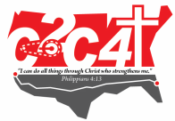

# The New School Building – Luanshya, Zambia

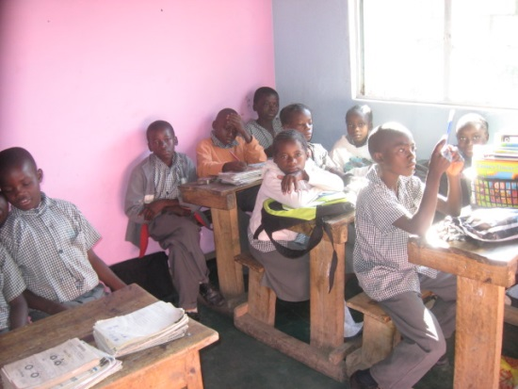

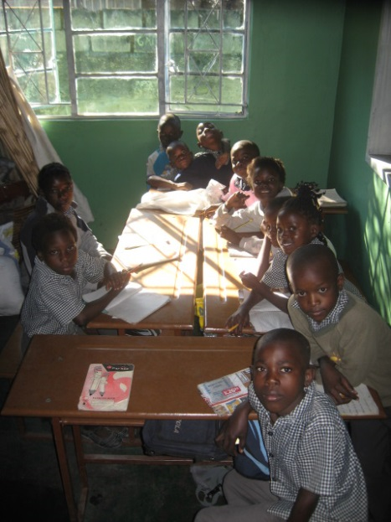

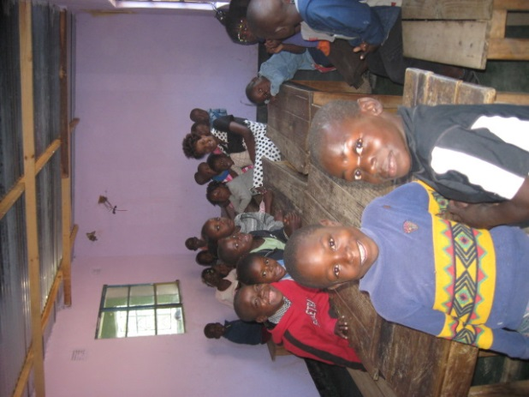

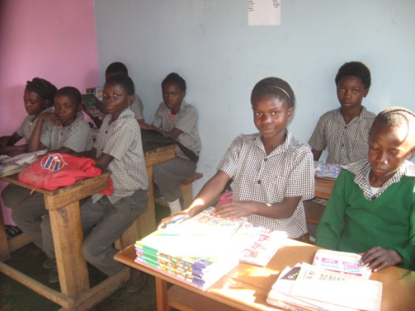

**Haven of Hope, Ndola Zambia**

**Permanent School Facility**

Property Purchase $18,000 (complete 6/2011)

Building Costs:

**Phase One (Foundation)**

Foundation Footing $ 5,000 (complete 9/20/2012)

Concrete Blockwork $11,100 (complete 12/1/2012)

Slab concrete $12,600 (complete 12/31/2012)

**Total Phase One: $28,700**

**Phase Two (Exterior & Structure)**

Blockwork $25,000 (complete 5/2013)

Structure & roof support $15,500 (complete 5/2013)

Plaster work $ 5,100 (complete 11/2013)

**Total Phase Two: $45,600**

**Phase Three (Roof & Interior Structure)**

Carpentry & Roof Structure $20,500 (complete 5/2014)

Roofing Materials $12,500 (7,800 still needed)

Interior Floors $ 2,900

Interior Doors & Hardware $ 8,200

**Total Phase Three: $44,100**

**Final Phase**

Electrical – Primary Installation $ 525

Electrical – Secondary Installation $ 9,200

Ceilings $11,200

Painting/Decorating $ 9,000

Door & Window Frames $ 9,200

Glazing $ 4,000

Sanitary Installation $15,400

Plumbing $ 4,500

**Total Final Phase: $63,025**

T-I-A (**T**his **I**s **A**frica) Contingency $15,300

Start of the Soakaway (sewer) $ 6,975

GRAND TOTAL: $221,700

# Saying good-bye…

We are saying good-bye to Marci Bidelspach as she will no longer be serving as Haven of Hope’s Sponsorship Liaison. We thank her for her nearly 6 years of service and care of the students of Haven of Hope Zambia!

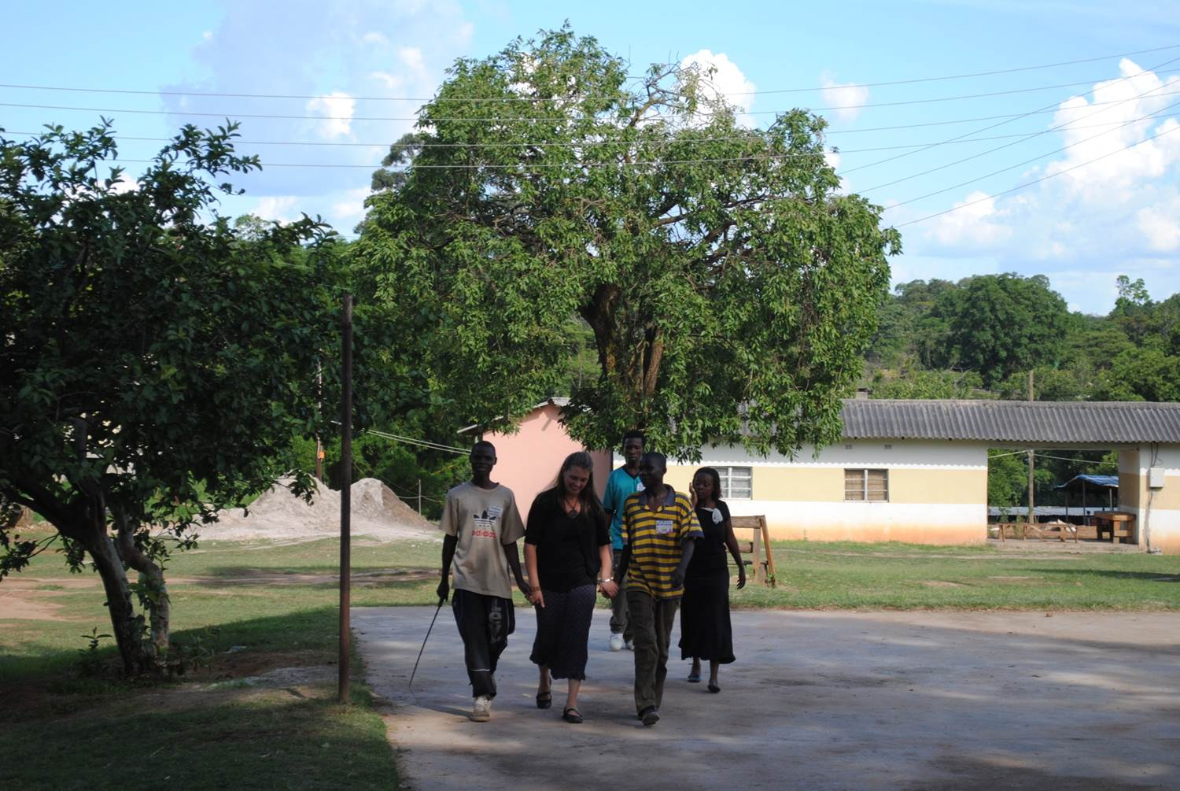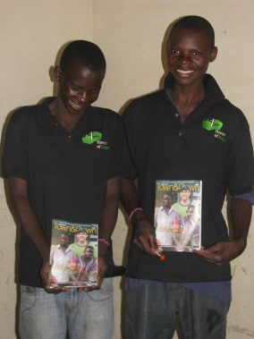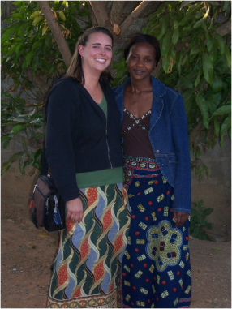

# Upcoming Trip to Zambia: Join in!!

It’s not too late to join this summer’s travel team! Come along and experience a joy like no other.

Trip dates: June 22 through July 3.

814.238.5913 or info@havenofhopezambia.org!

Check us out on Facebook!!

Haven of Hope Zambia

“Like” us!



##### CONTACT US!!

##### Haven of Hope Ministries

403 S. Allen Street, Suite 112-A

State College, PA 16801

##### Phone:

814-238-5913

##### E-Mail:

marci@havenofhopezambia.org

##### Web:

www.havenofhopezambia.org

C:\Documents and Settings\Owner\Local Settings\Temporary Internet Files\Content.IE5\GKR3TGOZ\MC900391178[1].wmfC:\Documents and Settings\Owner\Local Settings\Temporary Internet Files\Content.IE5\ZJ1DE3KH\MC900391180[1].wmfC:\Documents and Settings\Owner\Local Settings\Temporary Internet Files\Content.IE5\GKR3TGOZ\MC900391188[1].wmfC:\Documents and Settings\Owner\Local Settings\Temporary Internet Files\Content.IE5\ZJ1DE3KH\MC900391198[1].wmfC:\Documents and Settings\Owner\Local Settings\Temporary Internet Files\Content.IE5\M89XT626\MC900391184[1].wmf

**Special thanks to our Sponsors:**

Coldwell Banker University Reality/Dale Sherman,

Grace United Church of Christ,

Kissinger, Bigatel & Brower Realtor/Peter Chiarkas,

Nittany Christian School/Tony & Judith Wilson,

R&K Glass/Roger Huff,

Window World/ Chad & Shanelle Shirey,

Wm. L. Robinson Concrete Contractors, Inc.,

Dar Dunkelberger, Christine Fink,

Dave & Kethleen Geveke,

Kelly & Karen Hartzfield,

Melvin & Kathy Smith,

Ken & Kay Walk

Jeff & Kathy Spackman